AMMAN ARAB UNIVERSITY
جامعة عمان العربـيــــــة
College of Information Technology


كلية تكنولوجيا المعلومات

Title of The project

Students:
Name of Student 1 | 11111111

Supervisor:
Dr. Name of Supervisor

Amman - Jordan
2025/2026

Table of Contents
1.1 Problem Statement and project Scope page 1
1.2 Project Plan and Schedule
2. System Analysis page 2
2.1 Functional Requirements
2.2 Use Case Diagram
3. System Design page 3
3.1 ER-Diagram (if a database will be used)
3.2 User Interface (prototype)

  - Problem Statement and project Scope

The system has been facing problems due to its paper-based appointment
system. With the increase in the number of patients visiting, it has
become diﬃcult to manage the appointment system manually. Recording
of appointments and creating registers by pen and paper has become a
Problem Statement
The Noor Al-Iman Quran Memorization Center faces several operational challenges due to manual management of its data and processes. The core problems include:
- Data Fragmentation: There is difficulty in organizing and linking the personal details of students, teachers, and supervisors in a cohesive manner.
- Tracking Difficulties: The center lacks an automated mechanism to track daily memorization records, specific content mastered, and the dates of achievement for each student.
- Documentation Gaps: There is a deficiency in accurately documenting attendance records, status notes, and the distribution of motivational gifts to students.
- Organizational Constraints: Supervisors struggle to monitor classroom operations effectively, ensure maximum capacity limits are not exceeded, and assign curriculums to specific rooms efficiently.

Project Scope
The project aims to develop a comprehensive Database Management System (DBMS) to automate and enhance the administrative and educational operations of the center. The scope includes:
- Identity Management: Storing detailed personal information for all individuals (students, teachers, and supervisors), including unique IDs, phone numbers, addresses, and dates of birth.
- Academic Organization: Managing classrooms and linking them to specific curriculums—such as Aqeedah, Hadith, and Holy Quran—and assigned teachers .
- Performance Monitoring: Automating the tracking of memorization progress and recording daily attendance status, including notes on student performance.
- Incentive & Oversight System: Documenting gifts given to students to encourage progress and providing supervisors with tools to monitor classrooms and teaching quality.
- Data Integrity & Normalization: Implementing referential integrity to prevent the deletion of students with existing records and ensuring the database follows normalization standards (up to 3NF) to reduce redundancy.

  - Project Plan and Schedule
A Gantt Chart is a visual project management tool that displays tasks and activities as horizontal bars across a timeline. It is used to illustrate the project schedule, track progress, and clarify the sequence and duration of different project phases.
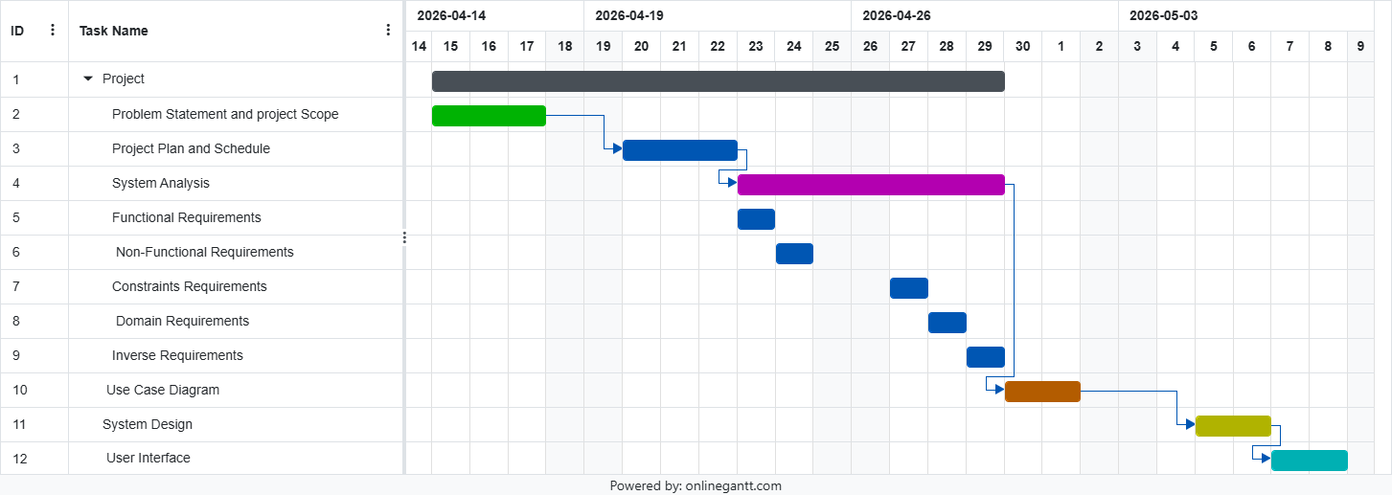
Figure 1: Gantt Chart of project

2. System Analysis

2.1 Functional Requirements

F1 Core Data Management: Ability to add, update, and delete records for students, teachers, and supervisors.

F2 Classroom & Curriculum Management: Linking each classroom to a specific curriculum and a responsible teacher.

F3 Memorization Recording: Logging the specific content memorized (e.g., Surah name) and the date for each student.

F4 Attendance Tracking: Enabling teachers to record attendance status (Present/Absent) with notes.

F5 Gift Management: Cataloging available gifts and documenting their distribution to students.

F6 . Queries & Reporting: Generating lists of students who never received gifts or calculating attendance counts.

2.2 Non-Functional Requirements

NF1. Data Integrity: Ensuring primary keys are unique and enforcing foreign key constraints to prevent orphan records.

NF2. Structural Normalization: Ensuring the system reaches the Third Normal Form (3NF) to minimize redundancy, specifically regarding addresses and zip codes.

NF3. Usability: Organizing data into clear, logical tables for administrative ease.

NF4. Accuracy: Ensuring every memorization or attendance entry is linked to a unique ID to prevent student mix-ups.

2.3 Constraints Requirements

CF1. Referential Integrity: A student record cannot be deleted if it is linked to existing attendance or memorization data.

CF2. Primary Key Requirements: Every student, teacher, and supervisor must have a unique ID to ensure data precision.

CF3. Classroom Capacity: The number of enrolled students must not exceed the specified MaxSize for any classroom.

CF4.Standardization: The system must resolve transitive dependencies, such as moving City and State to a separate ZipCodes table

2.4 Domain Requirements

DF1. Curriculum Structure: The system must support Islamic sciences categories, including Aqeedah, Tajweed, Hadith, Holy Quran, and Tafsir.

DF2. Memorization Records: Each entry must include the specific text memorized and the date of completion.

DF3, Incentive Culture: "Gifts" must be documented as part of the educational process, specifying the gift type and receipt date.

DF4. Administrative Roles: Personnel are categorized into specific roles (Student, Teacher, Supervisor) based on the "Person" superclass

2.5 Inverse Requirements

IF1. Prevention of Duplication: A student should not be allowed to enroll in multiple classrooms if it causes scheduling or curriculum conflicts.

IF2. Deletion Restrictions: The system must not allow the deletion of a teacher who is currently assigned to an active classroom.

IF3. Access Control: Students are prohibited from modifying their own attendance or memorization records; this authority is exclusive to teachers.

IF4. Mandatory Data: The system must reject entries for a "Person" that lack a First Name, Last Name, or Gender.
2.2 Use Case Diagram
To create a complete Use Case Diagram, you must include all core operations within the System Boundary: the Student (for enrolling and receiving), the Teacher (for attendance, recitation, and awarding), and the Supervisor (for oversight and management). Ensure every actor is accurately linked to their tasks, highlighting shared processes like Classroom Management and Gift Tracking to guarantee full technical coverage of the project requirements.
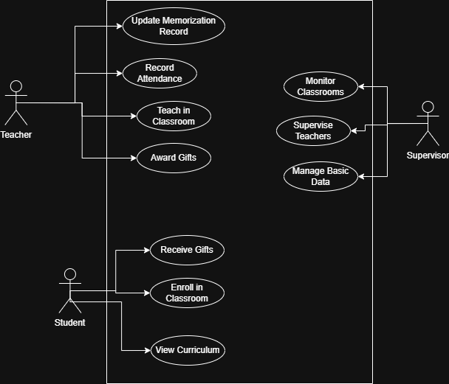

Figure 2: Use Case diagram of system

3. System Design
3.1 ER-Diagram
This ER Diagram represents the database architecture for the Noor Al-Iman Center, illustrating the relationships between students, teachers, and supervisors. It details how students enroll in classrooms , how teachers manage instruction and attendance , and how supervisors monitor the educational process. The diagram also highlights key tracking features, such as memorization records, curriculums, and the incentive system for awarding gifts.

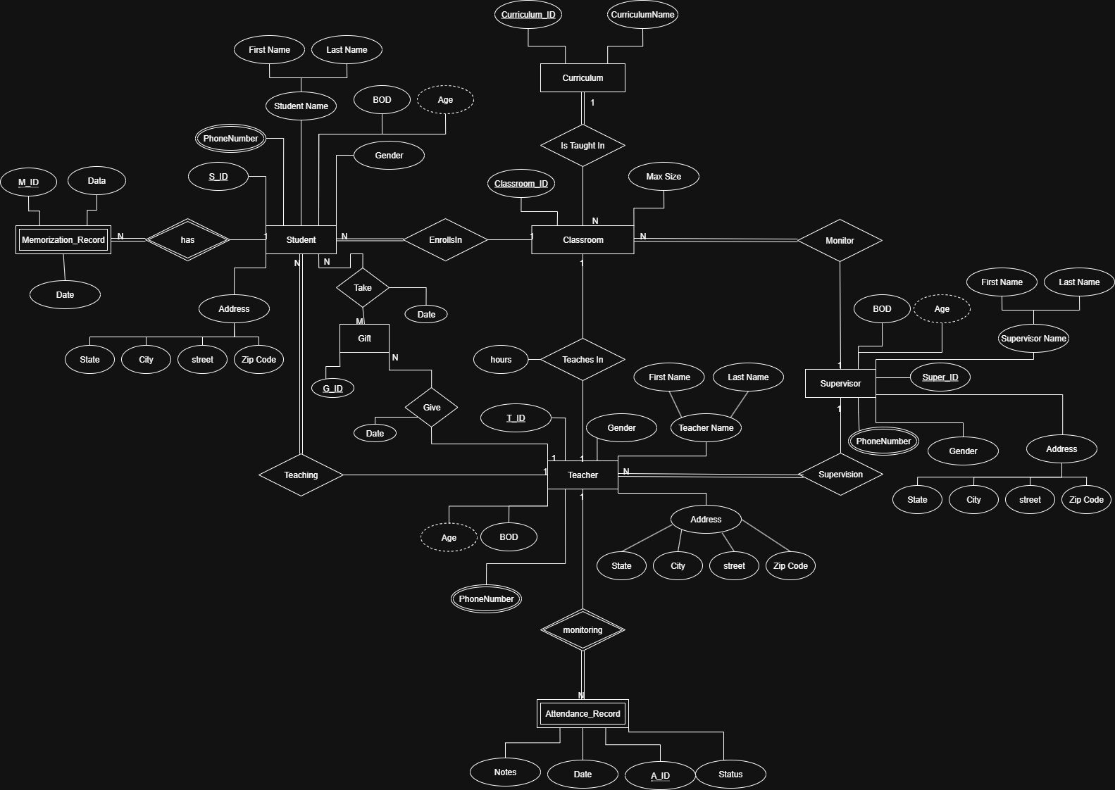

Figure 3: ER diagram of Appointment system

3.2 Mapping Diagram
This diagram presents the Relational Schema Mapping for the Noor Al-Iman system, translating the ER model into structured database tables. It organizes core entities like Student, Teacher, and Supervisor into primary tables with their respective attributes. Foreign keys are utilized to link students to Classrooms, Curriculums, and Teachers, ensuring data connectivity. Additionally, it handles multivalued attributes by creating separate tables for phone numbers and tracks activities through dedicated tables for Attendance, Memorization, and Gifts.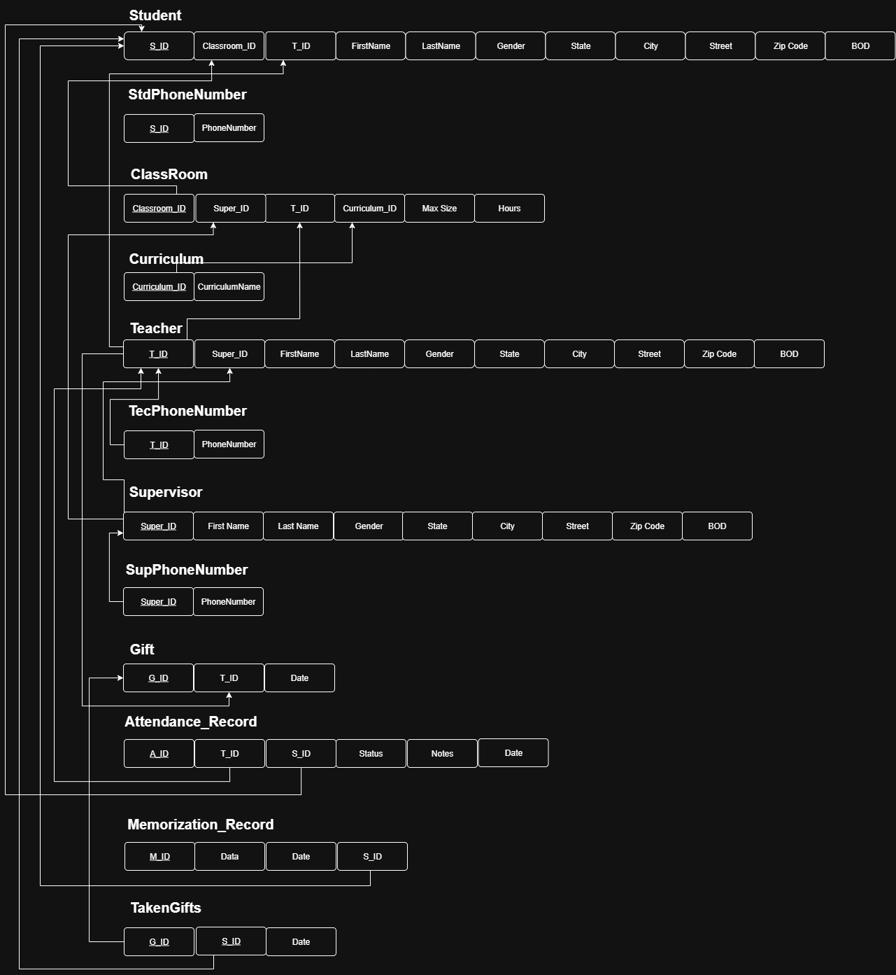
Figure 4:Mapping Diagram

3.3 User Interface (prototype)

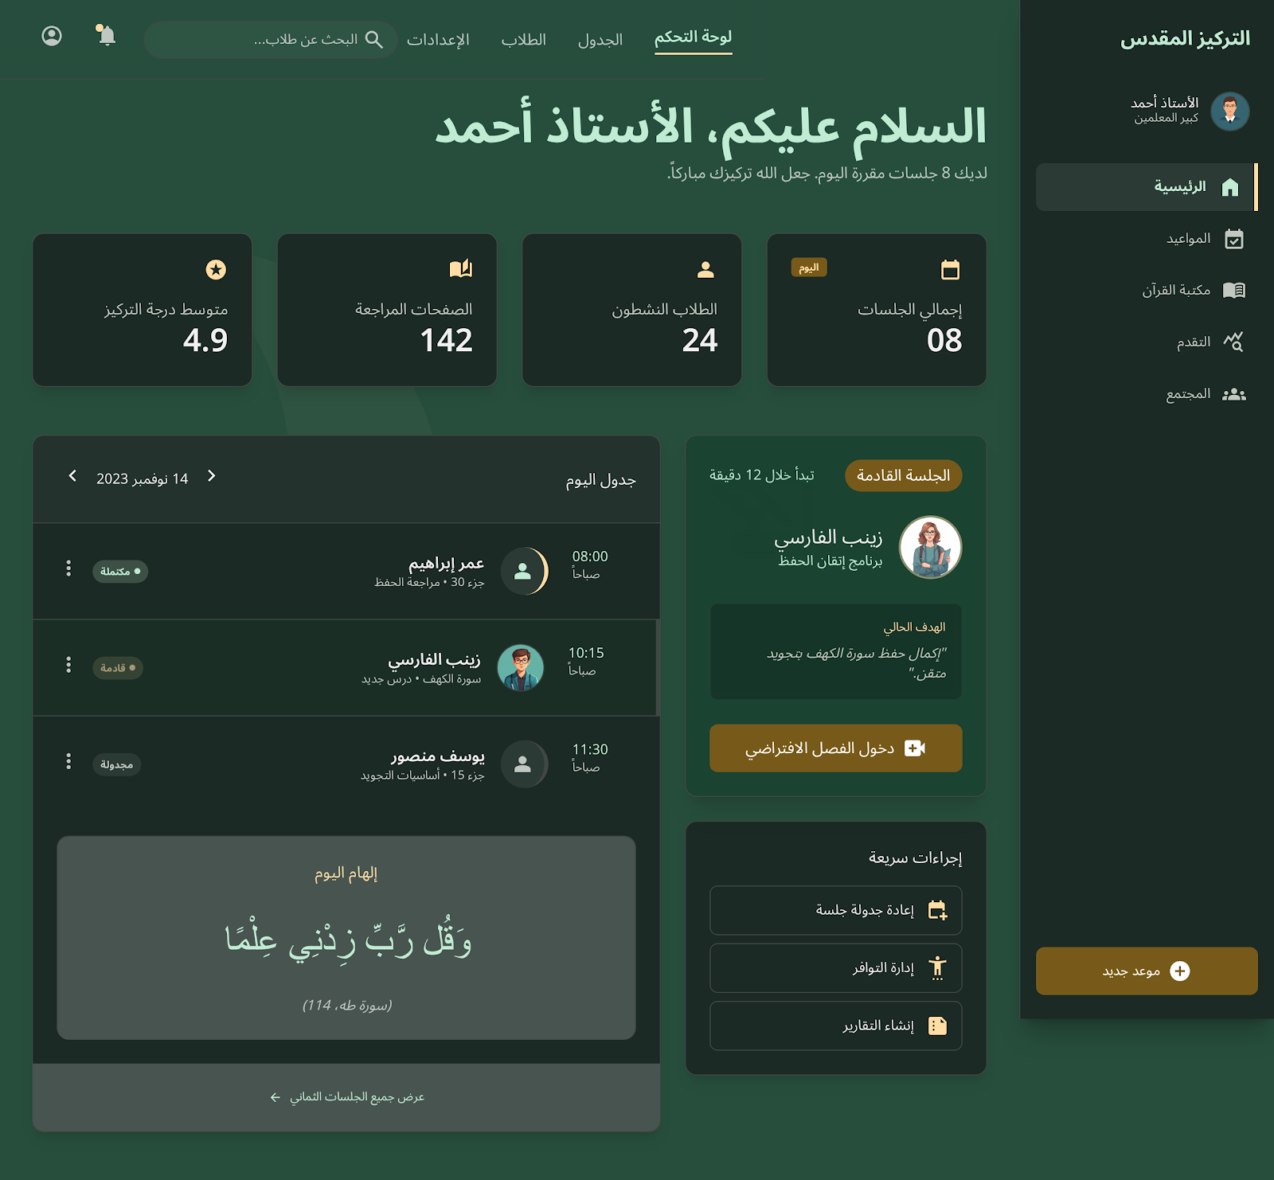

Figure 5: Main UI of Appointment system

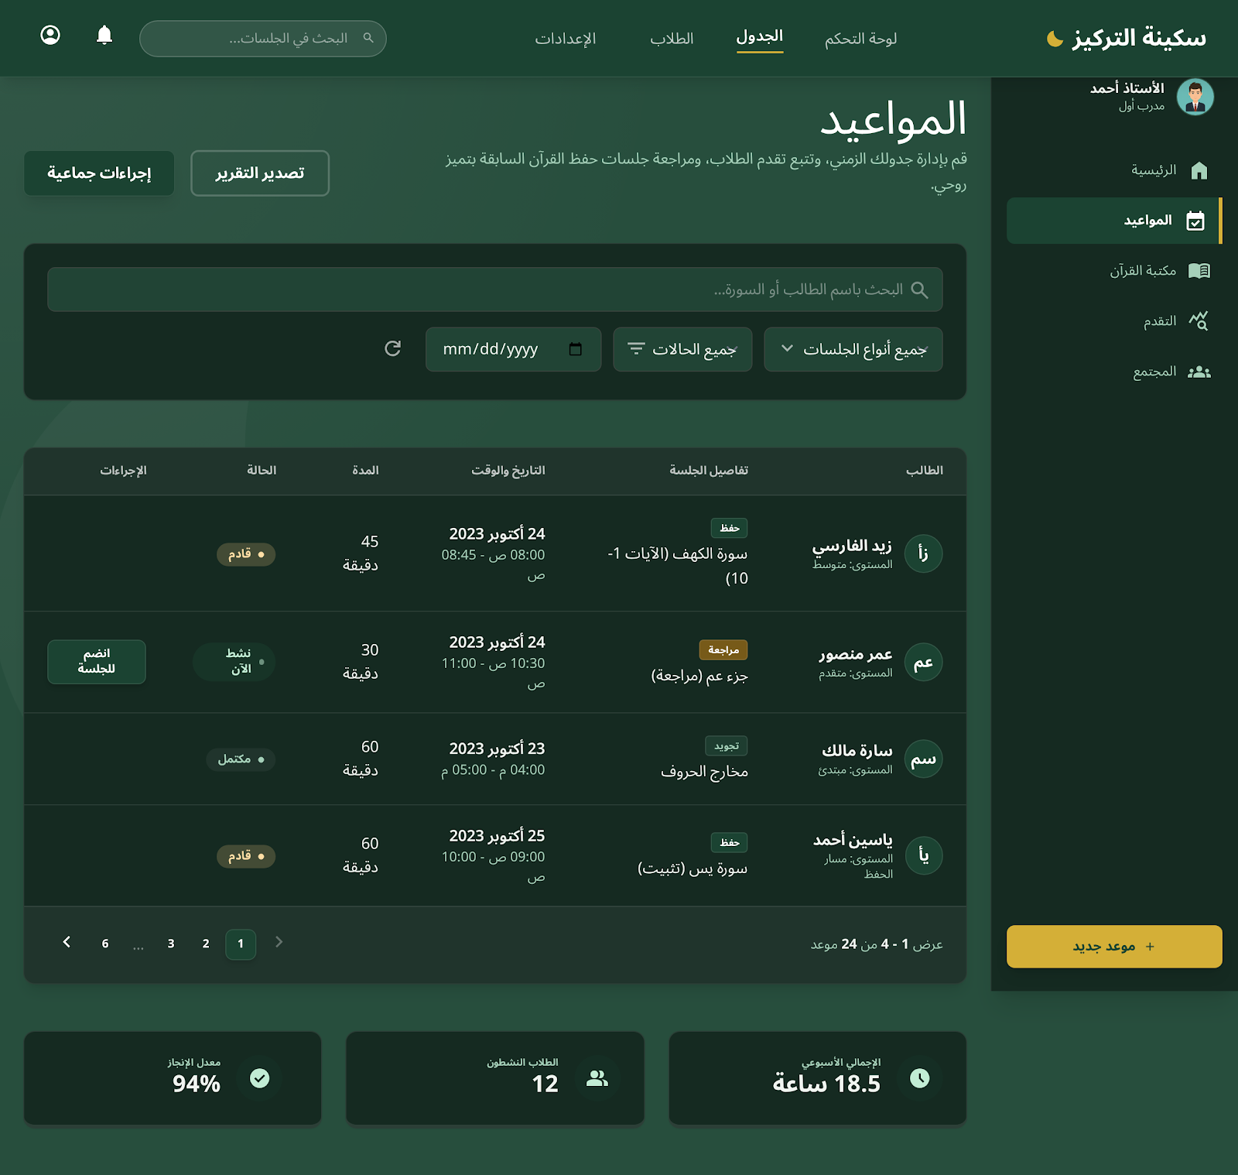

Figure 6: Show All UI of system

